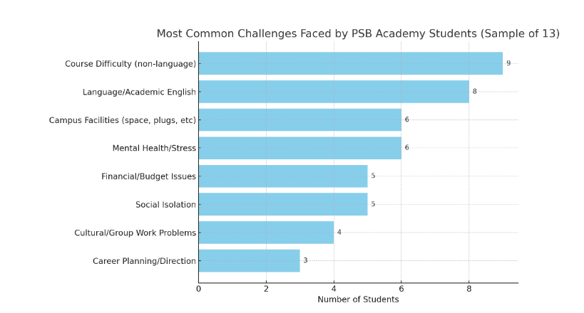
Key Findings
CATEGORYS
Course Difficulty (Non-language) 9
Language/Academic English Barriers 8
Campus Facilities Issues (Plugs, Study Rooms, Wi-Fi) 6
Mental Health / Stress 6
Financial/Budget Pressure 5
Social Isolation 5
Cultural/Group Work Conflict 4
Career Planning Confusion 3

Notable Patterns
- Language and Technical English
Many Chinese students cited technical English as a key obstacle.

Lecturer Communication: Accents and "fast speech" stressed international students; locals had no issues.

Even when students could understand general lectures, specific terms and accents posed difficulty.

Some avoid asking questions due to lack of confidence or unclear lecturer responses.

2. Mental Health and Social Isolation
Stress during exam season was mentioned frequently.

Few students used mental health services, although many knew of the “cozy corner”.

Homesickness and lack of friends were common among international students.

3. Campus Facilities
Lack of charging ports, quiet study rooms, and food options were common frustrations.

Many requested more self-study zones and better rest spaces.

4. Cross-Cultural Group Work
Foreign students might felt left out during group discussions, saying others often ignored their ideas or spoke too fast.

There were no major religion/gender-based violations reported, though a few mentioned uncomfortable comments online.

Suggested Features
Feature | Purpose
Academic Assistant (Might be multilingual ) | Help with technical English, allow easier communication with lecturers
Friend-Matching or Interest-Based Social (Ask staffs to assign events and provides information about recent events) | Combat isolation, encourage cultural exchange
Study Planner + Exam Prep help | Help students organize workload, reduce exam-related anxiety
Budget & Rent Track | Assist students in managing finances in Singapore
Campus Resource Assistant | Show quiet zones, cozy corner, toilet, food around campus
Cultural Sensitivity Help for Group Work | Improve collaboration among mixed-nationality groups

